
North Bengal International University

Lab Report: 01
Exp Name : SQL data definition for part of the university database

Subject : Database management system sessional
Subject Code : CSE 0612-3122

Submitted By:
Name : Md. Tanvir Rahman Pranto
Dept : CSE
Roll : 0712340012101005
Semester : 3nd Year, 5th semester.

Submitted To:
Name : Saifur Rahman
Designation : Lecturer
Dept : CSE
Date :

Design:
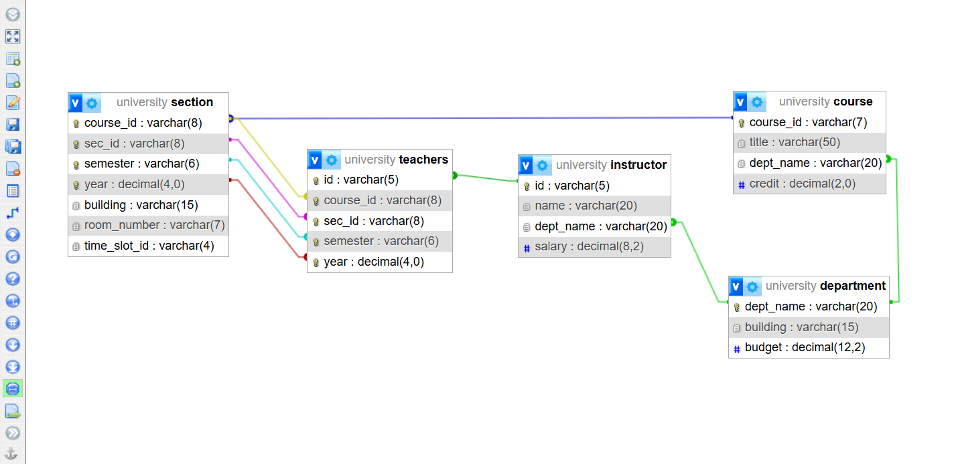

Table:
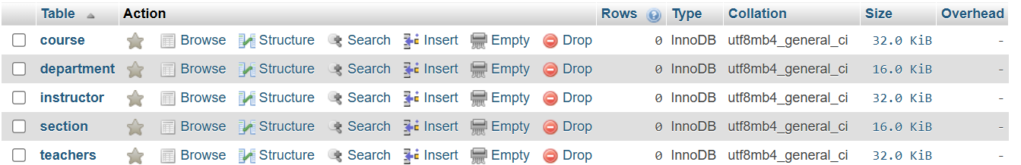

Index

S/N | Topics | Page
1.  2.  3.  4.  5.  6. | Experiment Name  Schema  Schema Design  SQL code  Design  Table | 1  1  1  2-3  4  4

